Marilyn’s Week 5 lab notes for 2505ICT

The three major classes of type

^{decorative}

Times Helvetica

New York Chicago

Aliasing and anti-aliasing

The image on the left above is The image on the right above is aliased … smoother …
it has jagged edges due to pixels it has been anti-aliased. The pixels
on the screen. The jaggedness next to the edges have been filled
can be seen better here: with less saturated versions of the
colour, which tricks the eyes.

In some systems you can turn anti-aliasing on. Try it on fonts over 12 point if they look jagged.

Fonts developed for screens

Below are some fonts that have been developed specifically for computer screens:

Geneva Geneva Geneva

Verdana Verdana Verdana

Arial Arial Arial

Georgia Georgia Georgia

Charcoal Charcoal Charcoal

Monaco Monaco Monaco

Be wary of using italics on computers. They are usually harder to read.

Some terminology - from Kahn and Lenk (1998). Principles of Typography for User Interface Design. Interactions, p.15 – 29.

Form and counterform:

Stems:

Bowls:

Ascenders, descenders, and x-height:

Letter spacing:

Word spacing:

Leading

Some rules:

1. The optimum number of characters-per-line the human eye can read is 80.

2. Dark type against a light surface is much easier to read than light type against a dark surface. Therefore, light type against a dark surface requires a font size two sizes larger to be equally legible.

More by Kahn:

Lack of typographic variation in the user interface can obscure information.

No typographic variation

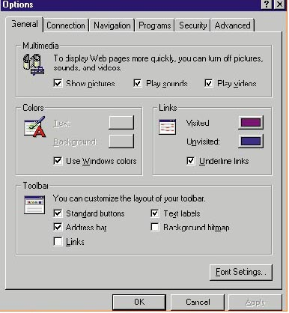

Better typographic variation

A hodge podge of typography and layout
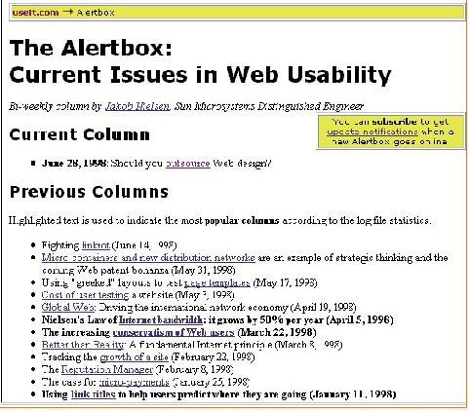

Better typography and layout

